5-Minute Film Festival: Videos on Kindness, Empathy, and Connection
May 10, 2013
- 11.1KSHARES
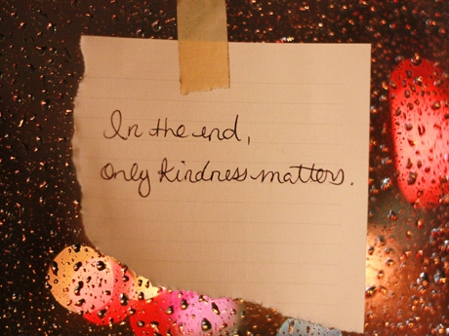
Photo Credit: SweetOnVeg via flickr (CC BY 2.0)
I'd like to offer up a video playlist to remind all of us about the power of empathy, kindness, and human connections. It's always a good time to practice gratitude for the relationships that sustain us all -- for the people who have taught us in a school setting and beyond, and for the young ones we are able to nurture and inspire.
I was also thinking about how many of us are living out the paradox of being ever more plugged in, and ever more aware of what's happening in our community via social media platforms, while at the same time, face-to-face interactions are less frequent than ever before. We are in constant touch, but barely touching. Watching these videos made me remember the importance of re-connecting, treating people with kindness and respect, and being generous and compassionate to both loved ones and strangers. If each of us pledged to do more of that, we'd make a better world for all of us to learn and grow in.

Video Playlist: Kindness, Empathy, and Connection
Watch the player below to see the whole playlist, or view it on YouTube.

- Rita Pierson: Every Kid Needs a Champion (07:49)
This talk from the TED Talks Education series was shared like mad in social media, and for good reason. Sadly, educator Rita Pierson passed in June 2013, but her words live on as an empowering call to action for all of us to build better relationships with kids.
- Take a Seat - Make a Friend? (04:53)
SoulPancake has been winning awards and making news (check out its wonderful Kid President videos, especially the Pep Talk). This heart-warming clip has strangers finding common ground in the most unusual of places.
- The Helping Hand - a story by Z. Murphy & L. Kranen (04:05)
The playful tone of this cute little film absolutely tickled me. Two enterprising grad students collaborate on a very unusual engineering project with a young boy they just met.
- Isaac and Amy - Yes to Love (04:23)
Yes, I'm a sap -- this one makes me weep openly. After Isaac's epic lip-dub proposal video to his girlfriend Amy went viral, he made this sequel as a celebration of kinship and all the relationships in his family's lives.
- Kindness Boomerang - "One Day" (05:45)
I love this short from Life Vest Inside, the New York non-profit founded by TED 2013 speaker and middle-school teacher Orly Wahba to encourage kindness. Bonus: Check out this remake by third graders.
- The Moth Presents James Braly: Oliver's Pink Bicycle (07:01)
The Moth is a wonderful podcast with true stories told live in front of an audience. Though the video quality is not great, as a parent of a toddler myself, I found this story to be a valuable lesson about acceptance.
- The Kindness Scientist (03:13)
Dr. Dacher Keltner, head researcher at UC Berkeley's Greater Good Science Center, speaks on how kindness and generosity not only make us happy -- but can contribute to good health!
- Generous Store (01:44)
I admit it, this one's a re-run, if you watched my Gratitude playlist last fall -- but I just adore it so much I have to share again. A Dutch chocolatier opens a store that only accepts promises of kind deeds as payment.

More Resources for Teaching Kindness and Empathy
If you agree that raising a generation of kinder, more compassionate, generous, and connected kids will benefit us all, the next step is to find resources to teach all those wonderful skills. Fortunately there are a number of organizations out there that offer tools for parents and educators to do just that. I've collected just a small sample below. But do remember that one of the best ways we can teach our kids to be thoughtful and empathetic is to model it ourselves! So start making time for kind and generous acts, no matter how small -- they can make a huge difference.
- Start Empathy Initiative from Ashoka
- Educator Resource Page from Random Acts of Kindness Foundation
- Roots of Empathy Program
- Classroom Resources from Teaching Tolerance
- Kindness Curriculum from Life Vest Inside
- The Dalai Lama Center for Peace and Education
- Education Resource Page from Greater Good Science Center
- The Kind Campaign
- Ripple Kindness Curriculum
- Educator Resource Page from Project Happiness
Amy Erin Borovoy (aka VideoAmy)'s Profile
Was this useful? Sign in to vote!

