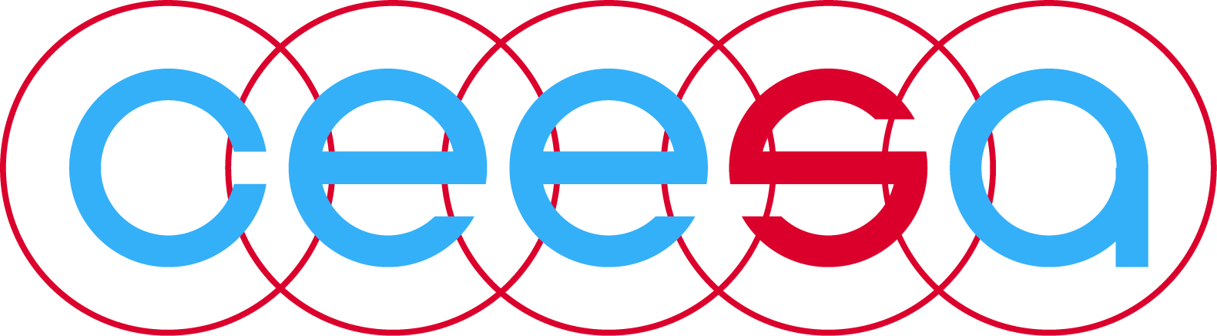

Teaching for Transformation:
Instructional Strategies that Make Student Thinking Visible
Presented by Dr. Fran Prolman
Saturday, January 25, 2014
8:30 AM - 4:30 PM
American School of Warsaw
This practical, kinesthetic, research-based institute offers dozens of instructional strategies to get into your students’ heads, practice cognitive empathy, differentiate your instruction based on real-time data, and make your student thinking visible in creative, critical thinking ways. This institute will raise your consciousness, validate your current skill set, and expand your repertoire of visible thinking skills for immediate application in your classroom.

This institute answers the following essential understandings:

• How do my beliefs about my role as a teacher and my students’ role as learner guide the decisions that I make in my classroom?
• What instructional strategies am I consciously choosing to expand rigor, higher level thinking, visible thinking and student reflection?
• How do I consciously incorporate 21st Century skills that make thinking visible?

This institute is grounded philosophically by an even bigger essential question,

“How do I ensure that my classroom instruction is consciously skillful on a daily basis??”

Program:

Friday January 24, 2014
Afternoon/Evening: Arrivals

Saturday January 25, 2014
08:00 AM Bus transfer from hotel to AS Warsaw
08:30 AM Start workshop
10:00 AM Morning break
12:30 PM Lunch
01:30 PM Continuation workshop
02:30 PM Afternoon break
04:00 PM End of workshop

Cost
- Workshop expenses including transportation to and from the school and hotel, snacks and lunch on the day of the workshop: free of charge for CEESA’s Full & Associate Members
Euro 100 for non CEESA members
- All participants are responsible for :
  - Transportation to and from Warsaw
  - Hotel costs which includes breakfast
  - Other meals

Dr. Fran Prolman
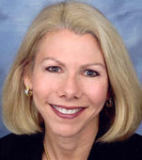
Fran Prolman is an independent consultant in Great Falls, VA, a Senior Consultant with Research for Better Teaching, and Vice President for Training for the Center for Arts in Basic Curriculum. She specializes in educational leadership, school improvement and instructional strategies as well as communication skills, critical thinking and organizational development.

She has been a two-time Fulbright Scholar in India and Israel. Dr. Prolman has almost 30 years of educational experience as a teacher, staff developer, administrator, graduate level university instructor and published author. Much of her time is spent in multifaceted work with school systems throughout the US focusing on teacher training methodology and administrative supervision and evaluation skills. She facilitates leadership retreats for teachers and administrators, delivers system-wide keynote speeches and workshops, and coaches administrators in the building of professional learning communities, instructional supervision, evaluation systems and the change process. Dr. Prolman earned her doctorate in teacher training and international education from George Washington University and a master’s degree in educational administration and curriculum and instruction from the University of Pennsylvania. DrFranny@aol.com

Workshop Registration
Registration for this workshop is online. Please click (or copy/paste) the link, which connects you to the online registration form. Deadline for registration is Friday January 10, 2014
https://docs.google.com/forms/d/1WDpCpHXWgrhzqZqVdh1RgV9DLRnUQp-BhFmKM9YOPZk/viewform

Hotel Room Reservation
Hotel rooms are blocked at the Sheraton Warsaw Hotel. Rooms should be reserved by sending in the hotel reservations form (see next page). Deadline for making hotel room reservations is Friday December 20, 2013. (Please note this is an earlier deadline than the workshop registration!) After this date the hotel cannot guarantee the special room rate, nor the availability.

Room Rates:
Weekdays (Mon-Thu) Weekend days (Fri-Sun)
• PLN 320 Single room per night • PLN 240 Single room per night
• PLN 392 Double room per night • PLN 280 Double room per night

Room rates are excluding 8% VAT, but are including buffet breakfast and internet WiFi access in the room.

Hotel Details:
Sheraton Warsaw Hotel
Bolesława Prusa 2, 00-493 Warszawa, Pologne
Tel: + 48 22 450 61 00
Fax: +48 22 450 69 0

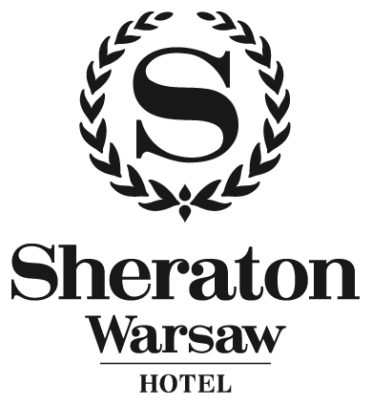

Hotel Reservation Form
CEESA / AMERCIAN SCHOOL OF WARSAW
21-26.01.2014
10320810
Week day:
21-24.01.2014 21-24.01.2014
Single room PLN 320 per night Double/Twin room PLN 392 per night
Weekend day:
24-26.01.2014 24-26.01.2014
Single room PLN 240 per night Double/Twin room PLN 280 per night

Prices include breakfast, internet WiFi access in the room, exclude 8% VAT
Surname: _______________________________ First Name:_____________________________
2nd Person in double/twin room
Surname: _______________________________ First Name:_____________________________
Company: ____________________________________________________________________________
Address: _____________________________________________________________________________
Phone: _______________________________ Fax: ___________________________________
Arrival Date: _____________________ Departure Date: _______________________
No of nights: ______
Smoking Room please Non-Smoking Room please
Special requests: _____________________________________________________________
Credit Card Number: __________________________ Exp. Date: ____________
Credit Card Type: _________________________________________________________

The credit card number given is to guarantee my booking and my account will not be debited until my departure. I agree that in case of non – arrival on the confirmed date, or cancellation I will be charged for a one night’s accommodation. Cancellations must be received prior to 16:00 up to 72 hours prior arrival.

Signature: __________________________________ Date: ________________________________

The rate offered is only available to registered delegates of the above meeting and are strictly subject to availability.

PLEASE FILL IN THIS FORM AND FAX IT TO +48 22 450 6901 by December 20, 2013
CONFIRMATION BY THE HOTEL We are pleased to confirm the above reservation

Confirmation number: ………………………………..
DATE: ……………………………………………………. SIGNATURE: ……………………………………………

