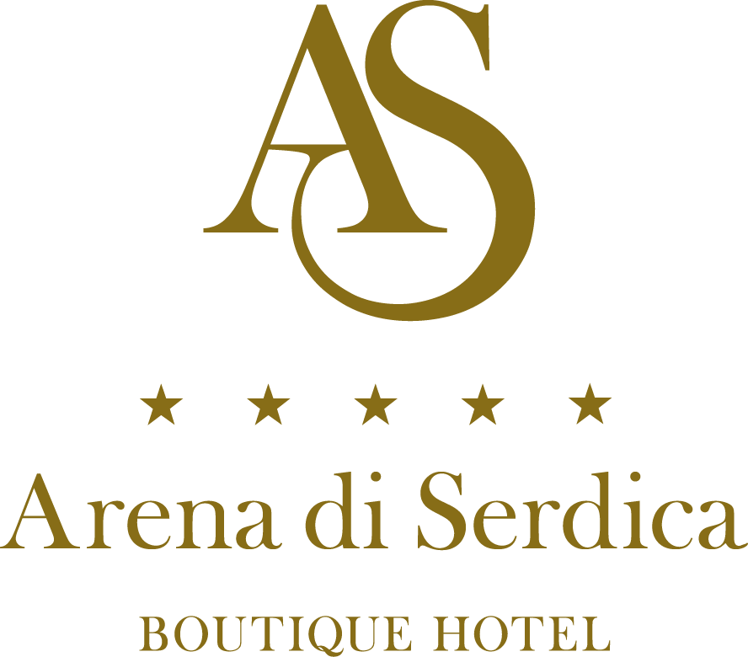

Transforming Schools Institute and
the Anglo-American School

22-27 January 2019

Arena di Serdica Boutique Hotel
Sofia, Bulgaria

HOTEL RESERVATION FORM

Mr. □ Mrs. □ Ms. □ Name: __________________ Surname: ________________

Country code: _____ Tel: ____________ Fax: ___________ E-mail: ______________
1. HOTEL RESERVATION

Tick the room type you require, indicate the total number of rooms and nights required.

Single room □ 115.67 €
Double room □ 136.34 €

Total No of nights: _________ No. of rooms: _________

Rates are per room, per night, inclusive of breakfast, internet access, fitness and 9% VAT and city tax of 0, 67 Euro.

Arrival: Departure:
Date: Date:

Please indicate the method of payment and guarantee reservation with credit card details:

Credit card name:_______________________ Number:________________________

Expiry date:___________________________ Signature:_______________________

2. TRANSFERS FROM / TO THE AIRPORT
Rate: EUR 20 /one way/
FROM the Airport: YES □ NO □
Flight number ________ Time of arrival: ________________

TO the Airport: YES □ NO □
Flight number ________ Time of departure: _____________

3. DEADLINE FOR RESERVATIONS: 08.01.2019

4. CANCELLATION POLICY

Cancellation must be made in written. Any cancellation of reservation made three days or less prior arrival results in a charge of the first night accommodation fee.

PLEASE COMPLETE AND RETURN TO:

Arena di Serdica Residence Hotel
2-4, Budapeshta Str., Sofia 1000, Bulgaria
Tel. + 359 2 810 77 88
Fax + 359 2 810 77 70
e-mail: reservations@arenadiserdica.com
www.arenadiserdica.com

