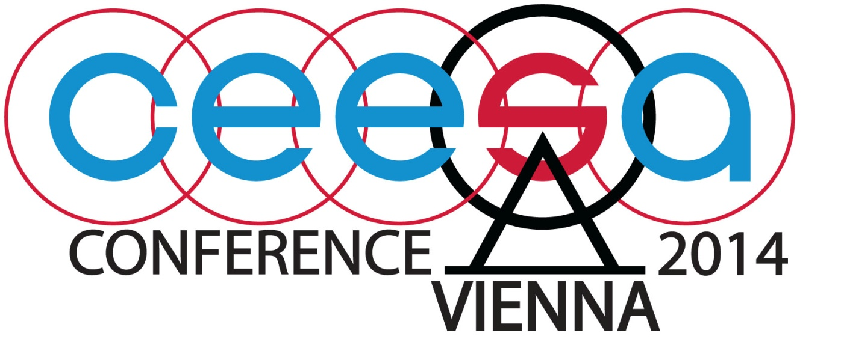
"Transforming Curriculum Through Collaboration"

Dear CEESA Community,
In the event the first welcome letter from Vienna to the CEESA Conference didn’t land on your desk, we want to once again encourage your attendance at the CEESA Conference in Vienna March 14-16. The CEESA staff and Board of Directors have done a superb job in designing a program that should appeal to teachers and administrators from all disciplines and divisions.
Taking advantage of all the wonderful sites, musical/theater productions and other amenities that this great city has to offer can enrich your experience at the conference. On behalf of the staff at AIS, we welcome you to this great city and want to offer whatever assistance we can in making your stay during the conference a very special happening.
CEESA Celebration
Location: This year's celebration will be held at the marvelous Palais Ferstel on Saturday March 15, which houses beautiful event halls, a shopping arcade and the famous Café Central. From construction in 1860 until 1925 the palace was the Austrian national bank. Partially destroyed in World War 2 the palace was official reopened in 1982 as an event location. Each year the AIS graduation is held in its halls.
Entertainment: The entertainment this year will be the live band,' Dan LoCascio and the Mean Streets'. Dan LoCascio is the Elementary Computers teacher at AIS and has been playing live shows in Vienna for many years. Their Chicago style rhythm and blues will have everyone on their feet dancing and having a great time.
Baby Sitter Service: Once again a baby sitter service will be available for the night of the celebration and other times during the weekend. A full list will be posted online soon.
Friday Night Dinner
Fifteen AIS Vienna staff members have picked their favorite restaurants and are looking forward to showing you a great night out on Friday March 14. The sign up list will be on the conference homepage soon. With only 15 spots available at each restaurant don’t forget to sign up!
Don’t Miss
While you are in Vienna there are some things that you should not miss.
The hotel is only a 15-minute walk or a short tram ride to the Ringstrasse, which circles the old town. Just a 5 minute walk from the hotel is the Belvedere Palace which houses Gustav Klimt's famous painting 'the kiss' as well as many other master works, beautiful rooms and gardens. For a full list of sights please click HERE.
Tours
As your time is short you might want to take a tour while you are here. The first choice would be a Fiaker or horse drawn carriage. For their history in Vienna and more information click HERE. Vienna also has hop on hop off tours HERE and Segway tours HERE if you want to go out on your own.
Miscellaneous
Currency: Since January 1, 2002 Austria has used the Euro as currency. Money can be exchanged at the Airport or you can use your bankcard at any bank machine to take money out.
Water: Vienna's tap water is the cleanest in the world and flows from the mountain springs in Lower Austria.
Weather: The weather varies from year to year in March however snow would not be expected. For Vienna weather click HERE
Cuisine: The chance to have an authentic Wiener Schnitzel should not be missed. For dessert, an Apelstrudel should top most lists and you are guaranteed to take home a Sachertorte (check your conference bag). Walking around the city you will see traditional Wurstel Stands (sausage stands) on most corners where a cheese filled sausages called a Kaiserkrainer is the main seller.
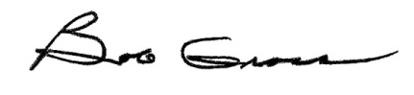
Come and join us,
Bob Gross, Director

